**Introduction of Take Note**

Take Note define features after login users can see the available features such a browse Home page, add notes, Show notes, Calculator, Image converter and Stop watch. After selecting each page users can able to do more things like users can add their content also can update that, can using calculator and so on.

**Using materials:** jsp, servlet, Hibernate, MySQL, Bootstrap, CSS, JavaScript.

**Login page**

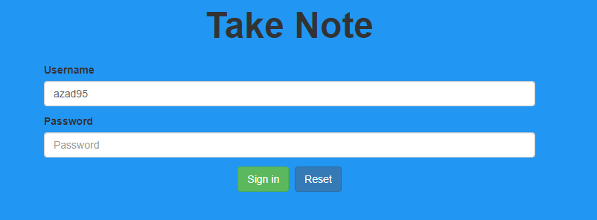

**Index page**

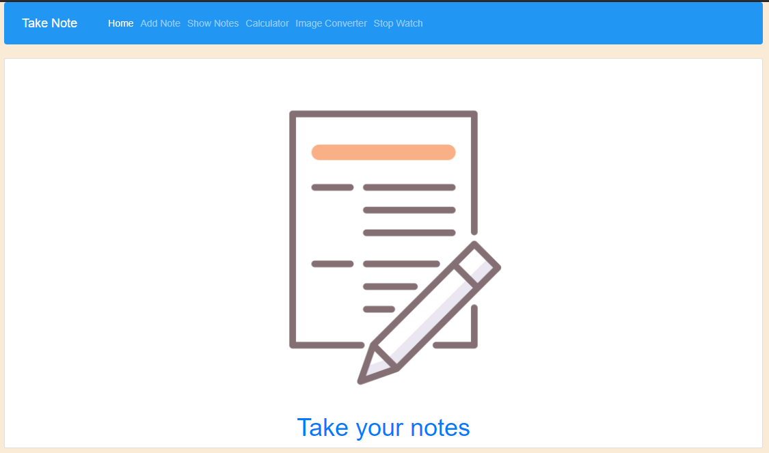

**Home page**

In home page have 5 buttons. Users can go to any page from home page by using that buttons.

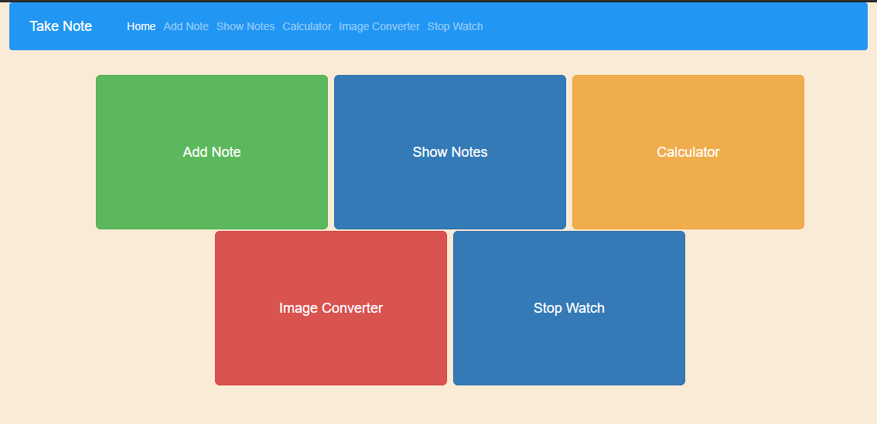

**Add Note**

In Add note, users can write their content with a good title. After saving that content it will save on MySQL Database. Also, users can save their content to their Desktop/laptop.

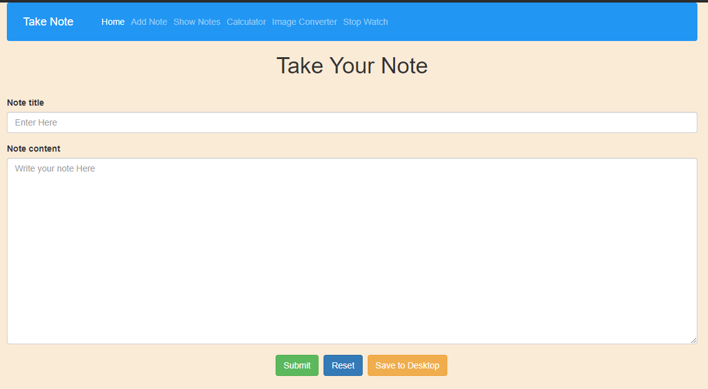

**Show Notes**

In Show notes, users can see their content. Content will show direct from MySQL Database to this page. After showing all content users can delete or update each content.

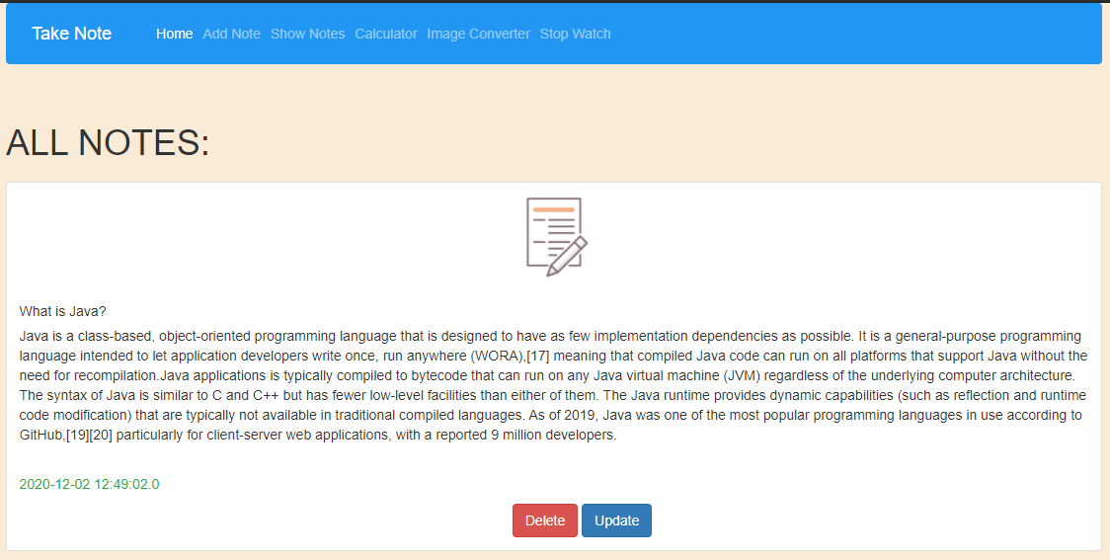

**Calculator**

In this page, users can calculate their easy mathematics.

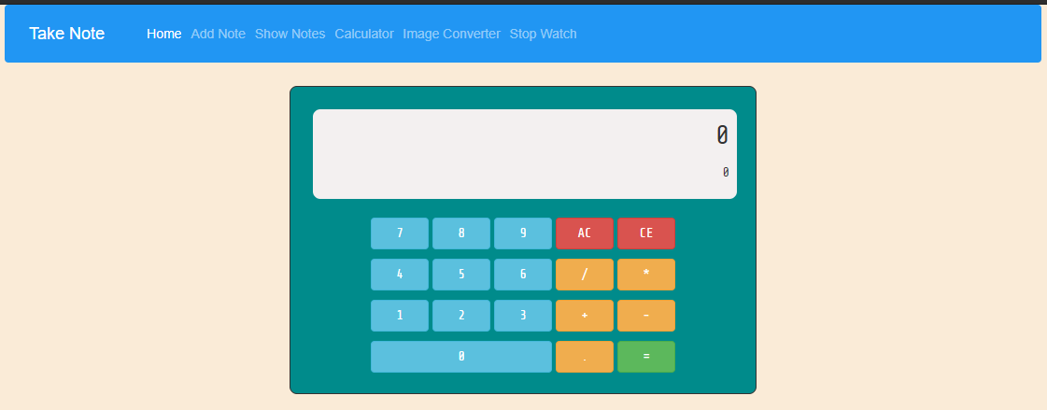

**Image converter**

Users can convert their images to JPEG or PNG or Gif.

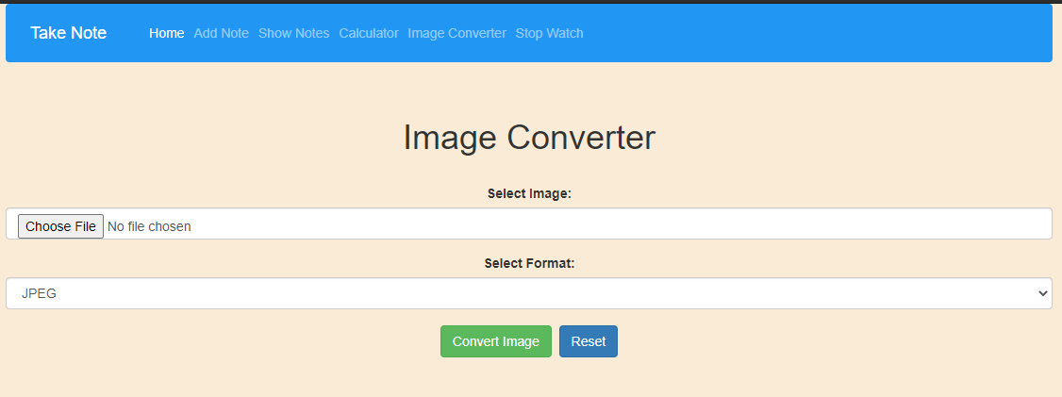

**Stop watch**

in this page users can count the time easily.

